1Q)

Ans)<!DOCTYPE html>
<html lang="en">
<head>
<meta charset="UTF-8">
<meta name="viewport" content="width=device-width, initial-scale=1.0">
<title>Document</title>
</head>
<body>
<h1>HTML stands for Hyper Text Markup Language</h1>
</body>
</html>

OUTPUT :-

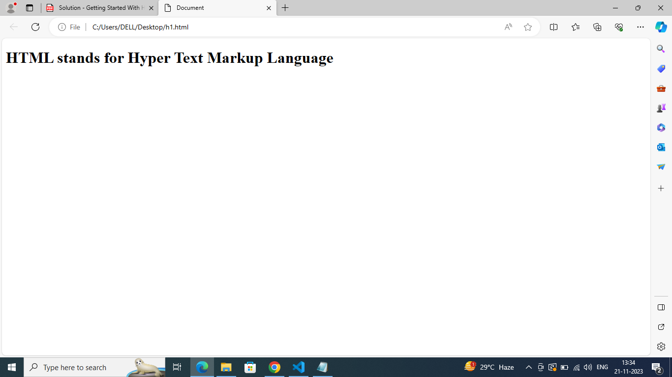
2Q)

Ans) <!DOCTYPE html>
<html lang="en">
<head>
<meta charset="UTF-8">
<meta name="viewport" content="width=device-width, initial-scale=1.0">
<title>HTML Comments Example</title>
</head>
<body>

<h1>This is a Heading</h1>
<p>This is a paragraph of text.</p>

<!-- This is a comment -->
<p><!-- This is another comment -->This paragraph contains a comment.</p>

<!--
This is a multi-line comment.
It spans multiple lines for additional information.
-->

</body>
</html>

OUTPUT :-

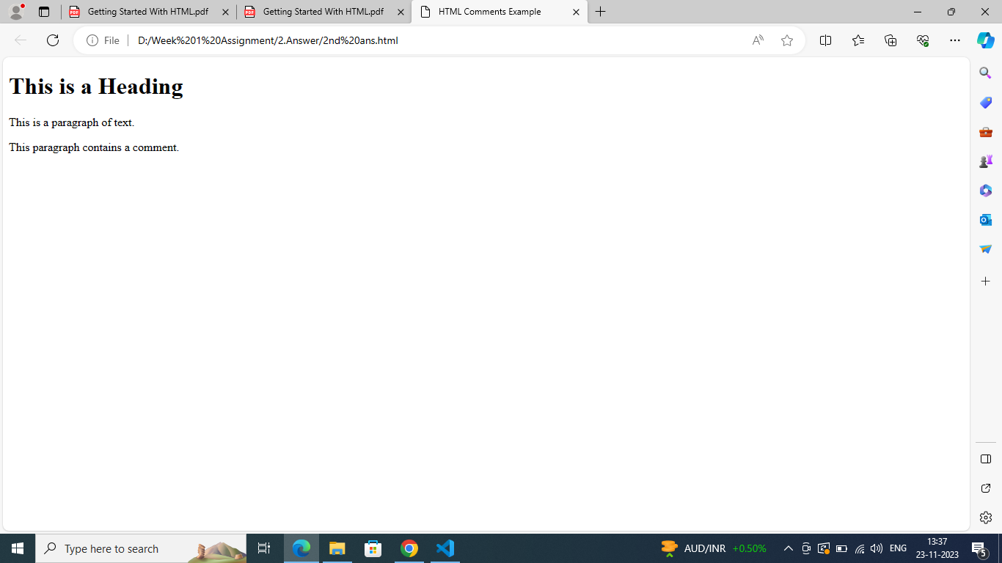

In HTML, comments are used to include non-executable annotations within the code.
They are meant for developers and do not affect the rendering of the web page.
Comments provide a way to document the code, add notes, or temporarily disable specific portions of HTML, helping developers understand the structure and functionality
of the code. Comments in HTML are created using the <!-- to start the comment and --> to end it. Anything between these delimiters is treated as a
comment and is ignored by the browser when rendering the webpage.

3Q)

Ans)<!DOCTYPE html>
<html lang="en">
<head>
<meta charset="UTF-8">
<meta name="viewport" content="width=device-width, initial-scale=1.0">
<title>Simple Web Page</title>
</head>
<body>

<h1>Happy New Year</h1>

<p>The arrival of the New Year marks a moment of reflection and anticipation as people bid
farewell to the past and embrace the possibilities of the future.</p>

<hr>

<p> It is a time for resolutions, a symbolic fresh start, and a chance to set new goals.</p>

<br>

<p. Whether celebrated with grand festivities or quiet contemplation, the New Year serves as a
universal reminder of the passage of time and the continuous cycle of renewal.></p.>

</body>
</html>

OUTPUT
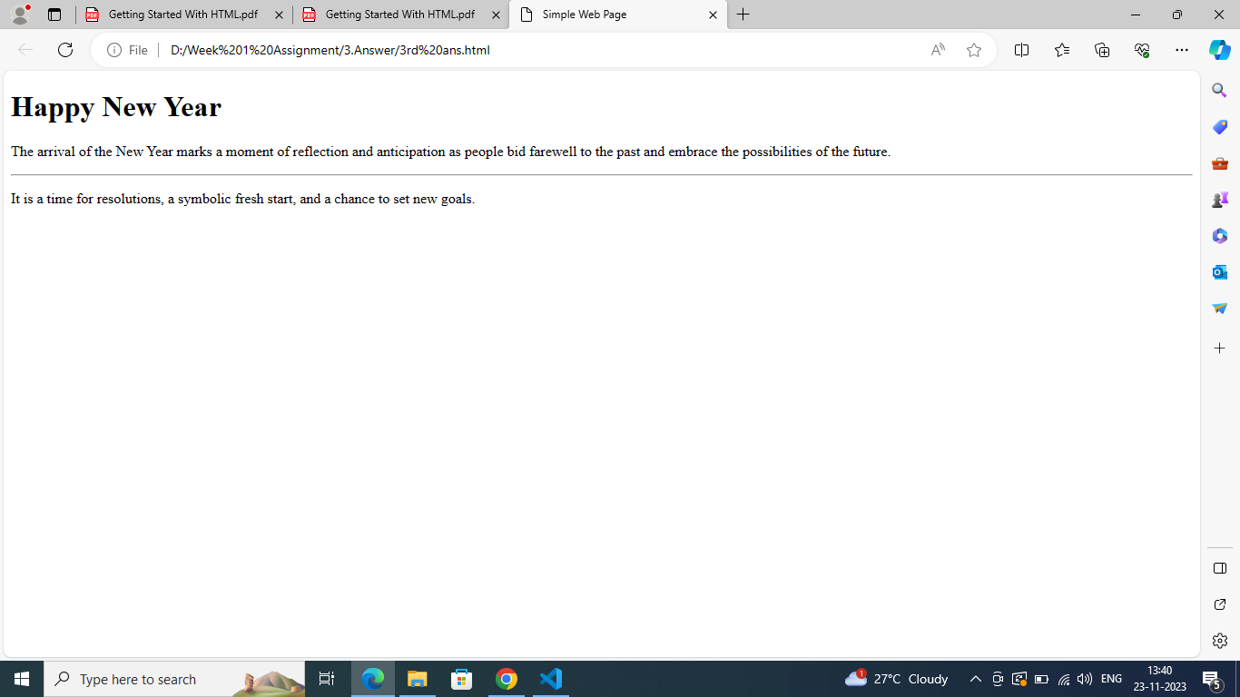

4Q)

Ans) Tag:
A tag is a keyword or code that specifies how a particular section of content should be formatted or styled. Tags are
enclosed in angle brackets (< and >). Tags are used to define the beginning and end of an HTML element.

Example of a tag: <p>

In this example, <p> is the opening tag, and it indicates the beginning of a paragraph.
To close the paragraph, you would use the closing tag </p>.
Element:
An element is a complete set of tags that define a specific piece of content on a web page. It consists of an opening tag, content, and a closing tag. The content is the actual text or multimedia that the element represents.

Example of an element:

5Q)

Ans) The DOCTYPE declaration in HTML is a special instruction placed at the beginning of
an HTML document to
specify the version of HTML being used. It ensures proper rendering and parsing by
web browsers. The most
common declaration, <!DOCTYPE html>, indicates the use of HTML5, the latest version
of HTML.

